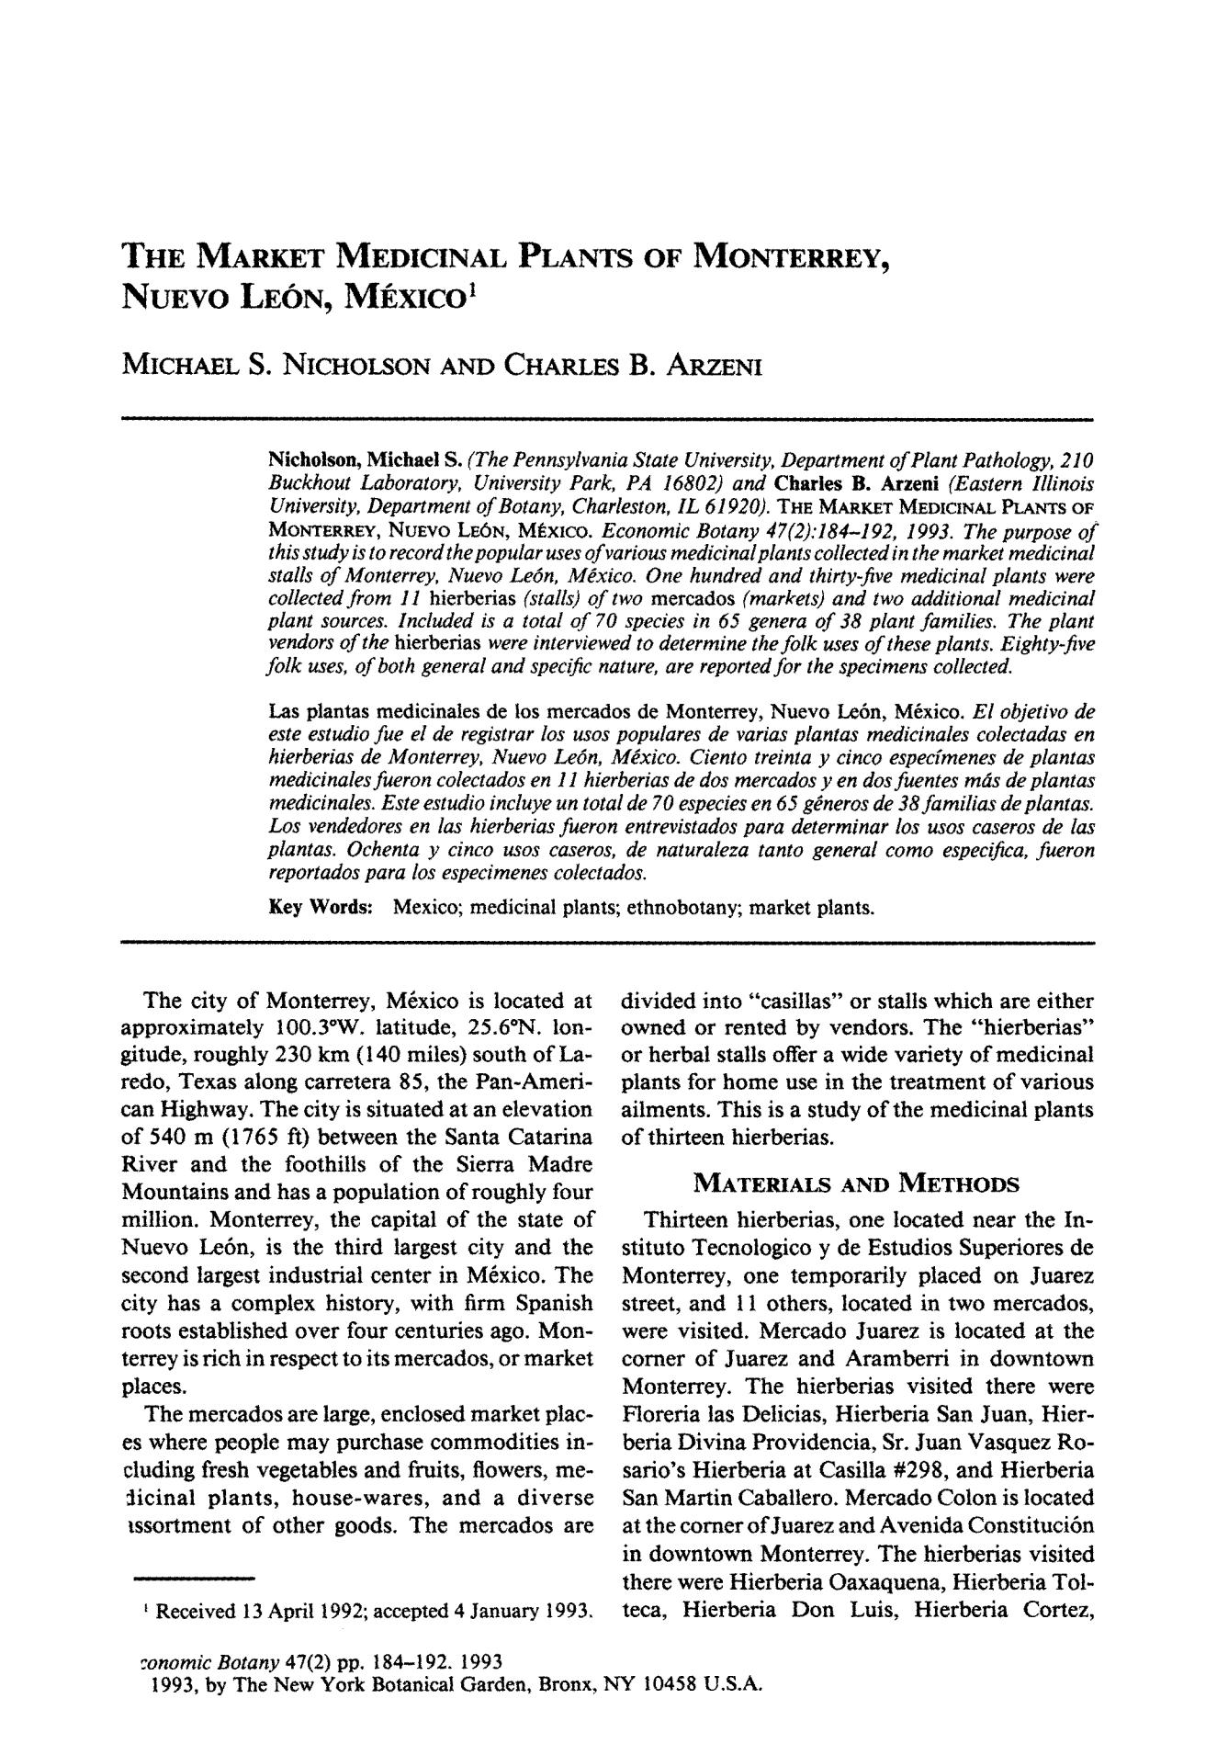

**THE MARKET MEDICINAL PLANTS OF MONTERREY,**

**NUEVO LEON, MI** **xIco 1**

MICHAEL S. NICHOLSON AND CHARLES B. ARZENI

Nicholson, Michael S. *(The Pennsylvania State University, Department o f Plant Pathology, 210* *Buckhout Laboratory, University Park, PA 16802) and* Charles B. Arzeni *(Eastern Illinois University, Department of Botany, Charleston, IL 61920).* THE MARKETMEDICINALPLANTSOFMONTERREY,NUEVOLEON, M~XICO. *Economic Botany 47(2):184-192, 1993. The purpose o f* *this study is to record the popular uses of various medicinat plants collected in the market medicinal stalls o f Monterrey, Nuevo Le6n, M~xico. One hundred and thirty-five medicinal plants were collected from I 1* hierberias *(stalls) o f two* mercados *(markets) and two additional medicinal plant sources. Included is a total o f 70 species in 65 genera of 38 plant families. The plant vendors of the* hierberias *were interviewed to determine the folk uses of these plants. Eighty-five folk uses, of both general and specific nature, are reported for the specimens collected.*

Las plantas medicinales de los mercados de Monterrey, Nuevo Le6n, M6xico. *El objetivo de* *este estudio fue el de registrar los usos populates de varias plantas medicinales colectados en hierberias de Monterrey, Nuevo Le6n, M~xico. Ciento treinta y cinco especfmenes de plantas medicinales fueron colectados en 11 hierberias de dos mercados y e n dos fuentes m~s de plantas medicinales. Este estudio incluye un total de 70 especies en 65 g~neros de 38 famtTios de plantas. Los vendedores en las hierberias fueron entrevistados para determinar los usos caseros de los plantas. Ochenta y cinco usos caseros, de naturaleza tanto general como especifica, fueron reportados para los especimenes colectados.*

Key Words: Mexico; medicinal plants; ethnobotany; market plants.

The city of Monterrey, M6xico is located at approximately 100.3*W. latitude, 25.6~ lon-gitude, roughly 230 km (140 miles) south of La-redo, Texas along carretera 85, the Pan-Ameri-can Highway. The city is situated at an elevation of 540 m (1765 ft) between the Santa Catarina River and the foothills of the Sierra Madre Mountains and has a population of roughly four million. Monterrey, the capital of the state of Nuevo Le6n, is the third largest city and the second largest industrial center in M6xico. The city has a complex history, with firm Spanish roots established over four centuries ago. Mon-terrey is rich in respect to its mercados, or market places.

The mercados are large, enclosed market plac-es where people may purchase commodities in-cluding fresh vegetables and fruits, flowers, me-:licinal plants, house-wares, and a diverse lssortment of other goods. The mercados are

Received 13 April 1992; accepted 4 January 1993.

divided into "casillas" or stalls which are either owned or rented by vendors. The "hierberias" or herbal stalls offer a wide variety of medicinal plants for home use in the treatment of various ailments. This is a study of the medicinal plants of thirteen hierberias.

MATERIALS AND METHODS

Thirteen hierberias, one located near the In-stituto Tecnologico y de Estudios Superiores de Monterrey, one temporarily placed on Juarez street, and 11 others, located in two mercados, were visited. Mercado Juarez is located at the comer of Juarez and Aramberri in downtown Monterrey. The hierberias visited there were Floreria las Delicias, Hierberia San Juan, Hier-beria Divina Providencia, Sr. Juan Vasquez Ro-sario's Hierberia at Casilla #298, and Hierberia San Martin Caballero. Mercado Colon is located at the comer of Juarez and Avenida Constituci6n in downtown Monterrey. The hierberias visited there were Hierberia Oaxaquena, Hierberia Tol-teca, Hierberia Don Luis, Hierberia Cortez,

*7onomic Botany* 47(2) pp. 184-192. 1993

1993, by The New York Botanical Garden, Bronx, NY 10458 U.S.A.

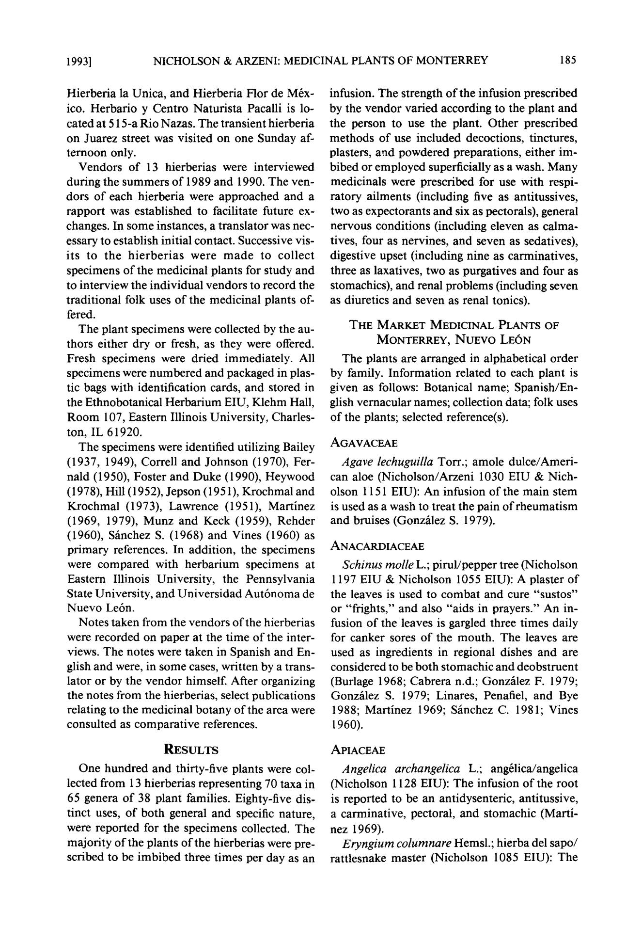1 9 9 3 ] NICHOLSON & ARZENI: MEDICINAL PLANTS OF MONTERREY 185

Hierberia la Unica, and Hierberia Flo r de M6x-ico. Herbario y Centro Naturista Pacalli is lo-cated at 515-a Rio Nazas. The transient hierberia on Juarez street was visited on one Sunday af-ternoon only.

Vendors o f 13 hierberias were interviewed during the summers o f 1989 and 1990. The ven-dors o f each hierberia were approached and a rapport was established to facilitate future ex-changes. In some instances, a translator was nec-essary to establish initial contact. Successive vis-its to th e h i e r b e r i a s were m a d e to collec t specimens o f the medicinal plants for study and to interview the individual vendors to record the traditional folk uses o f the medicinal plants of-fered.

The plant specimens were collected by the au-thors either dry or fresh, as they were offered. Fresh specimens were dried immediately . All specimens were numbere d and packaged in plas-tic bags with identification cards, and stored in the Ethnobotanical Herbarium EIU, Klehm Hall, R o o m 107, Eastern Illinois University, Charles-ton, IL 61920.

The specimens were identified utilizing Bailey (1937, 1949), Correll and Johnson (1970), Fer - nald (1950), Foster and Duke (1990), Heywood (1978), Hill (1952), Jepson (1951), Krochmal and Krochma l (1973), Lawrence (1951), Martinez (1969, 1979), Munz and Keck (1959), Rehder (1960), Sfinchez S. (1968) and Vines (1960) as primary references. In addition, the specimens were compare d with herbarium specimens at Eastern Illinois University, the Pennsylvania State University, and U n i v e r s i d a d Aut6nom a de Nuevo Le6n.

Notes taken from the vendors o f the hierberias were recorded on paper at the time o f the inter-views. The notes were taken in Spanish and En-glish and were, in some cases, written by a trans-lator or by the vendo r himself. After organizing the notes from the hierberias, select publications relating to the medicinal botany o f the area were consulted as comparativ e references.

RESULTS

One hundred and thirty-five plants were col-lected from 13 hierberias representing 70 taxa in

1. genera o f 38 plant families. Eighty-five dis-tinct uses, o f both general and specific nature, were reported for the specimens collected. The majorit y o f the plants o f the hierberias were pre-scribed to be i m b i b e d three times per day as an

infusion. The strength o f the infusion prescribed by the vendo r varied according to the plant and the person to use the plant. Other prescribed methods o f use included decoctions, tinctures, plasters, and powdered preparations, either im - bibe d or employe d superficially as a wash. Man y medicinals were prescribed for use with respi-ratory ailments (including five as antitussives, two as expectorants and six as pectorals), general nervous conditions (including eleven as calma - tives, four as nervines, and seven as sedatives), digestive upset (including nine as carminatives, three as laxatives, two as purgatives and four as stomachics), and renal problems (including seven as diuretics and seven as renal tonics).

THE MARKET MEDICINAL PLANTS OF

MONTERREY, NUEVO LEON

The plants are arranged in alphabetical order by family. Information related to each plant is given as follows: Botanical name; Spanish/En - glish vernacular names; collection data; folk uses o f the plants; selected reference(s).

AGAVACEAE

*Agave lechuguilla* Torr.; amole dulce/Ameri -can aloe (Nicholson/Arzeni 1030 EIU & Nich - olson 1151 EIU): A n infusion o f the mai n stem is used as a wash to treat the pain o f rheumatis m and bruises (Gonz~ilez S. 1979).

ANACARDIACEAE

*Schinus molle* L.; pirul/pepper tree (Nicholson1197 EI U & Nicholson 1055 EIU): A plaster o f the leaves is used to comba t and cure "sustos" or "frights," and also "aid s in prayers . " A n in-fusion o f the leaves is gargled three times daily for canker sores o f the mouth . The leaves are used as ingredients in regional dishes and are considered to be both stomachic and deobstruent (Burlage 1968; Cabrera n.d.; Gonz/dez F. 1979; Gonzhlez S. 1979; Linares, Penafiel, and Bye 1988; Martinez 1969; Sfinchez C. 1981; Vines 1960).

APIACEAE

*Angelica archangelica* L.; ang61ica/angelica(Nicholson 1128 EIU): The infusion o f the root is reported to be an antidysenteric, antitussive, a carminative, pectoral, and stomachic (Marti -

nez 1969).

*Eryngiurn columnare* Hemsl.; hierba del sapo/rattlesnake master (Nicholson 1085 EIU): The

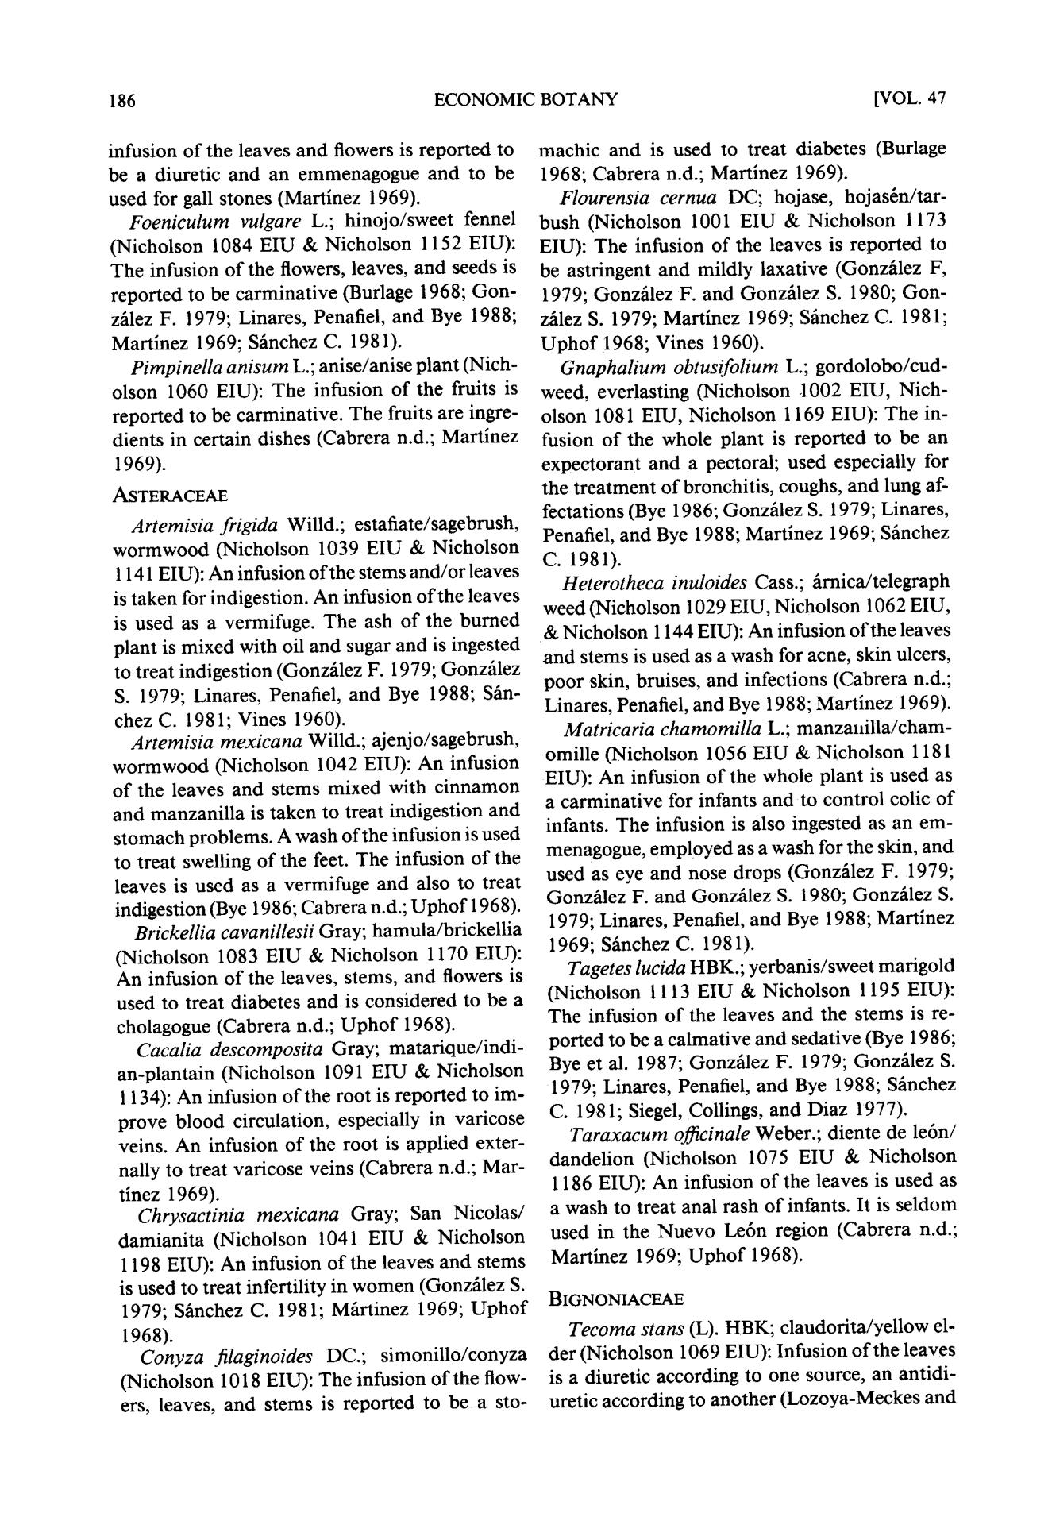186 ECONOMIC BOTANY [VOL. 47

infusion of the leaves and flowers is reported to be a diuretic and an emmenagogue and to be used for gall stones (Martinez 1969).

*Foeniculum vulgare* L.; hinojo/sweet fennel(Nicholson 1084 EIU & Nicholson 1152 EIU): The infusion of the flowers, leaves, and seeds is reported to be carminative (Burlage 1968; Gon-z~lez F. 1979; Linares, Penafiel, and Bye 1988; Martinez 1969; S~nchez C. 1981).

*Pimpinella anisum* L.; anise/anise plant (Nich-olson 1060 EIU): The infusion of the fruits is reported to be carminative. The fruits are ingre-dients in certain dishes (Cabrera n.d.; Martinez 1969).

ASTERACEAE

*Artemisia frigida* Willd.; estafiate/sagebrush,wormwood (Nicholson 1039 EIU & Nicholson 1141 EIU): An infusion of the stems and/or leaves is taken for indigestion. An infusion of the leaves is used as a vermifuge. The ash of the burned plant is mixed with oil and sugar and is ingested to treat indigestion (Gonz~lez F. 1979; Gonzhlez S. 1979; Linares, Penafiel, and Bye 1988; S~n-

chez C. 1981; Vines 1960).

*Artemisia mexicana* Willd.; ajenjo/sagebrush,wormwood (Nicholson 1042 EIU): An infusion of the leaves and stems mixed with cinnamon and manzanilla is taken to treat indigestion and stomach problems. A wash of the infusion is used to treat swelling of the feet. The infusion of the leaves is used as a vermifuge and also to treat indigestion (Bye 1986; Cabrera n.d.; Uphof 1968).

*Brickellia cavanillesii* Gray; hamula/brickellia(Nicholson 1083 EIU & Nicholson 1170 EIU): An infusion of the leaves, stems, and flowers is used to treat diabetes and is considered to be a cholagogue (Cabrera n.d.; Upho f 1968).

*Cacalia descomposita* Gray; matarique/indi-an-plantain (Nicholson 1091 EIU & Nicholson 1134): An infusion of the root is reported to im-prove blood circulation, especially in varicose veins. An infusion of the root is applied exter-nally to treat varicose veins (Cabrera n.d.; Mar-

tinez 1969).

*Chrysactinia mexicana* Gray; San Nicolas/damianita (Nicholson 1041 EIU & Nicholson 1198 EIU): An infusion of the leaves and stems is used to treat infertility in women (Gonzhlez S. 1979; S~nchez C. 1981; M~rtinez 1969; Upho f

1968).

*Conyza filaginoides* DC.; simonillo/conyza(Nicholson 1018 EIU): The infusion of the flow-ers, leaves, and stems is reported to be a sto-

machic and is used to treat diabetes (Burlage 1968; Cabrera n.d.; Martinez 1969).

*Flourensia cernua* DC; hojase, hojasrn/tar-bush (Nicholson 1001 EIU & Nicholson 1173 EIU): The infusion of the leaves is reported to be astringent and mildly laxative (Gonzhlez F, 1979; Gonz~lez F. and Gonz~lez S. 1980; Gon-z~ilez S. 1979; Martinez 1969; S~nchez C. 1981; Uphof 1968; Vines 1960).

*Gnaphalium obtusifolium* L.; gordolobo/cud-weed, everlasting (Nicholson 1002 EIU, Nich-olson 1081 EIU, Nicholson 1169 EIU): The in-fusion of the whole plant is reported to be an expectorant and a pectoral; used especially for the treatment of bronchitis, coughs, and lung af-fectations (Bye 1986; Gonzfilez S. 1979; Linares, Penafiel, and Bye 1988; Martlnez 1969; S~nchez C. 1981).

*Heterotheca inuloides* Cass.; firnica/telegraphweed (Nicholson 1029 EIU, Nicholson 1062 EIU,

* Nicholson 1144 EIU): An infusion of the leaves and stems is used as a wash for acne, skin ulcers, poor skin, bruises, and infections (Cabrera n.d.; Linares, Penafiel, and Bye 1988; Martinez 1969).

*Matricaria chamomilla* L.; manzalfilla/cham-omille (Nicholson 1056 EIU & Nicholson 1181 EIU): An infusion of the whole plant is used as a carminative for infants and to control colic of infants. The infusion is also ingested as an em-menagogue, employed as a wash for the skin, and used as eye and nose drops (Gonzfilez F. 1979; Gonzfilez F. and Gonz~lez S. 1980; Gonz~lez S. 1979; Linares, Penafiel, and Bye 1988; Martinez 1969; S~hachez C. 1981).

*Tagetes lucida* HBK.; yerbanis/swect marigold(Nicholson 1113 EIU & Nicholson 1195 EIU): The infusion of the leaves and the stems is re-ported to be a calmative and sedative (Bye 1986; Bye et al. 1987; Gonz~lez F. 1979; Gonz~lez S. 1979; Linares, Penafiel, and Bye 1988; Shnchez C. 1981; Siegel, Collings, and Diaz 1977).

*Taraxacum officinale* Weber.; diente de le6n/

dandelion (Nicholson 1075 EIU & Nicholson 1186 EIU): An infusion of the leaves is used as a wash to treat anal rash of infants. It is seldom used in the Nuevo Le6n region (Cabrera n.d.; Martlnez 1969; Upho f 1968).

BIGNONIACEAE

*Tecoma stans* (L). HBK; claudorita/yellow el-der (Nicholson 1069 EIU): Infusion of the leaves is a diuretic according to one source, an antidi-uretic according to another (Lozoya-Meckes and

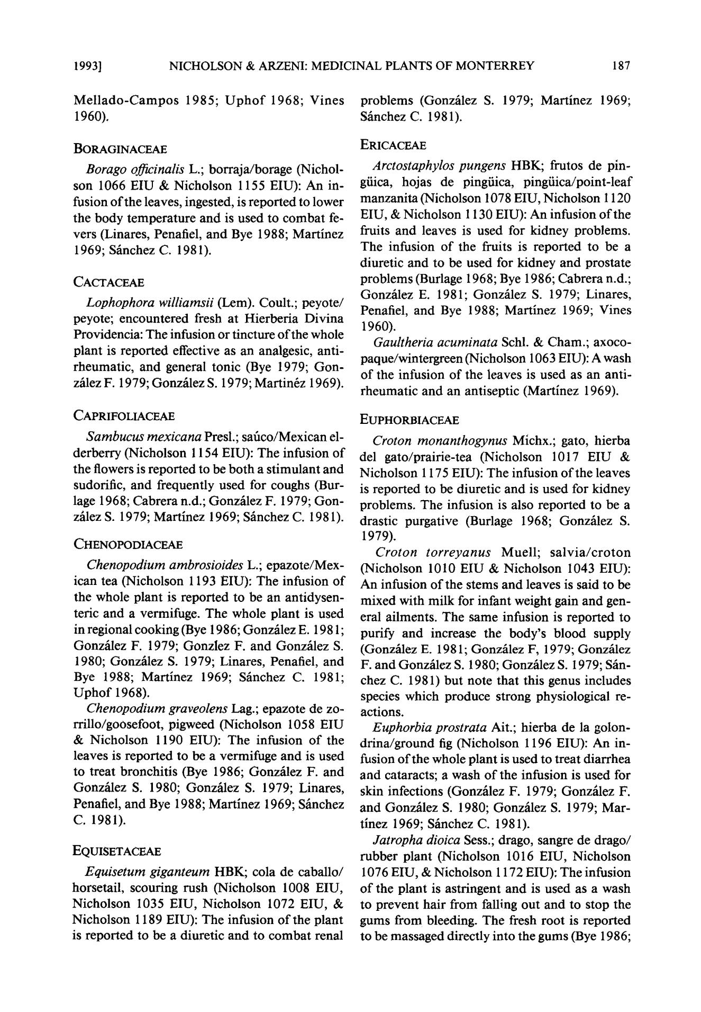1 9 9 3 ] NICHOLSON & ARZENI: MEDICINAL PLANTS OF MONTERREY 187

M e l l a d o - C a m p o s 1985; U p h o f 1968; Vines 1960).

BORAGINACEAE

*Borago officinalis* L.; borraja/borage (Nichol-son 1066 EIU & Nicholson 1155 EIU): An in-fusion of the leaves, ingested, is reported to lower the body temperature and is used to combat fe-vers (Linares, Penafiel, and Bye 1988; Martinez 1969; Sfinchez C. 1981).

CACTACEAE

*Lophophora williamsii* (Lem). Coult.; peyote/peyote; encountered fresh at Hierberia Divina Providencia: The infusion or tincture of the whole plant is reported effective as an analgesic, anti-rheumatic, and general tonic (Bye 1979; Gon-zfilez F. 1979; Gonzfilez S. 1979; Martin6z 1969).

CAPRIFOLIACEAE

*Sambucus mexicana* Presl.; safico/Mexican el-derberry (Nicholson 1154 EIU): The infusion of the flowers is reported to be both a stimulant and sudorific, and frequently used for coughs (Bur-lage 1968; Cabrera n.d.; Gonzfilez F. 1979; Gon-zfilez S. 1979; Martinez 1969; Sfinchez C. 1981).

CHENOPODIACEAE

*Chenopodium ambrosioides* L.; epazote/Mex-ican tea (Nicholson 1193 EIU): The infusion of the whole plant is reported to be an antidysen-teric and a vermifuge. The whole plant is used in regional cooking (Bye 1986; Gonzfilez E. 1981; Gonzfilez F. 1979; Gonzlez F. and Gonzfilez S. 1980; Gonzfilez S. 1979; Linares, Penafiel, and Bye 1988; Martinez 1969; Sfinchez C. 1981; Upho f 1968).

*Chenopodium graveolens* Lag.; epazote de zo-rrillo/goosefoot, pigweed (Nicholson 1058 EIU

* Nicholson 1190 EIU): The infusion of the leaves is reported to be a vermifuge and is used to treat bronchitis (Bye 1986; Gonzfilez F. and Gonzhlez S. 1980; Gonz~lez S. 1979; Linares, Penafiel, and Bye 1988; Martinez 1969; Sfinchez C. 1981).

EQUISETACEAE

*Equisetum giganteum* HBK; cola de caballo/horsetail, scouring rush (Nicholson 1008 EIU, Nicholson 1035 EIU, Nicholson 1072 EIU, & Nicholson 1189 EIU): The infusion of the plant is reported to be a diuretic and to combat renal

problems (Gonzfilez S. 1979; Martinez 1969; Sfinchez C. 1981).

ERICACEAE

*Arctostaphylos pungens* HBK; frutos de pin-g/iica, hojas de pingiiica, pingiiica/point-leaf manzanita (Nicholson 1078 EIU, Nicholson 1120 EIU, & Nicholson 1130 EIU): An infusion of the fruits and leaves is used for kidney problems. The infusion of the fruits is reported to be a diuretic and to be used for kidney and prostate problems (Burlage 1968; Bye 1986; Cabrera n.d.; Gonzfilez E. 1981; Gonz~ilez S. 1979; Linares, Penafiel, and Bye 1988; Martinez 1969; Vines 1960).

*Gaultheria acuminata* Schl. & Cham.; axoco-paque/wintergreen (Nicholson 1063 EIU): A wash of the infusion of the leaves is used as an anti-rheumatic and an antiseptic (Martinez 1969).

EUPHORBIACEAE

*Croton monanthogynus* Michx.; gato, hierbadel gato/prairie-tea (Nicholson 1017 EIU & Nicholson 1175 EIU): The infusion of the leaves is reported to be diuretic and is used for kidney problems. The infusion is also reported to be a drastic purgative (Burlage 1968; Gonzfilez S. 1979).

*Croton torreyanus* Muell; salvia/croton(Nicholson 1010 EIU & Nicholson 1043 EIU): An infusion of the stems and leaves is said to be mixed with milk for infant weight gain and gen-eral ailments. The same infusion is reported to purify and increase the body's blood supply (Gonzfilez E. 1981; Gonzfilez F, 1979; Gonzfilez F. and Gonzfilez S. 1980; Gonzfilez S. 1979; Sfin-chez C. 1981) but note that this genus includes species which produce strong physiological re-actions.

*Euphorbia prostrata* Ait.; hierba de la golon-drina/ground fig (Nicholson 1196 EIU): An in-fusion of the whole plant is used to treat diarrhea and cataracts; a wash of the infusion is used for skin infections (Gonzfilez F. 1979; Gonzfilez F. and Gonzfilez S. 1980; Gonzfilez S. 1979; Mar-tinez 1969; Sfinchez C. 1981).

*Jatropha dioica* Sess.; drago, sangre de drago/rubber plant (Nicholson 1016 EIU, Nicholson 1076 EIU, & Nicholson 1172 EIU): The infusion of the plant is astringent and is used as a wash to prevent hair from falling out and to stop the gums from bleeding. The fresh root is reported to be massaged directly into the gums (Bye 1986;

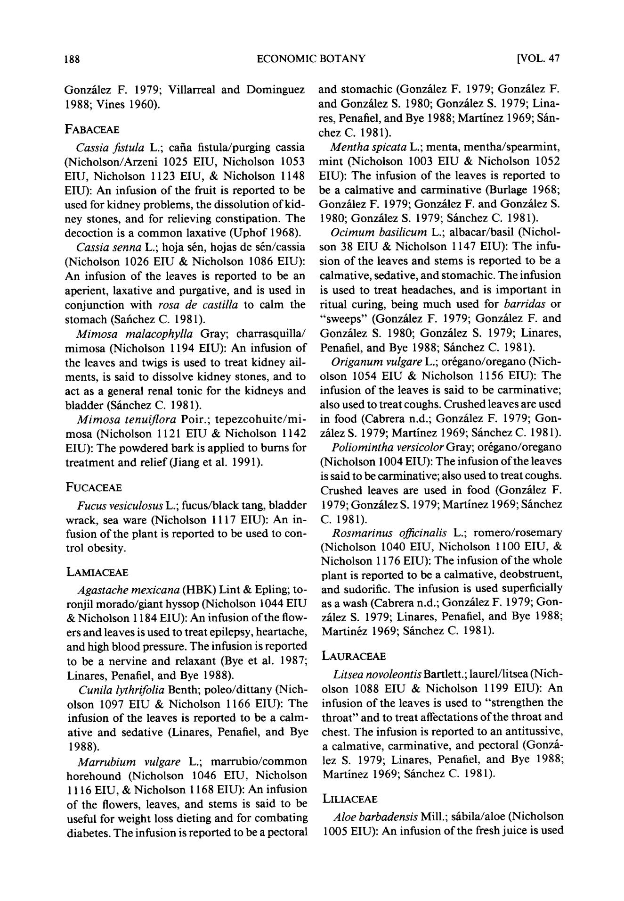188 ECONOMIC BOTANY [VOL. 47

Gonz~lez F. 1979; Villarreal and Dominguez 1988; Vines 1960).

FABACEAE

*Cassia fistula* L.; carla fistula/purging cassia(Nicholson/Arzeni 1025 EIU, Nicholson 1053 EIU, Nicholson 1123 EIU, & Nicholson 1148 EIU): An infusion of the fruit is reported to be used for kidney problems, the dissolution of kid-ney stones, and for relieving constipation. The decoction is a common laxative (Uphof 1968).

*Cassia senna* L.; hoja srn, hojas de srn/cassia(Nicholson 1026 EIU & Nicholson 1086 EIU): An infusion of the leaves is reported to be an aperient, laxative and purgative, and is used in conjunction with *rosa de castilla* to calm the stomach (Safichez C. 1981).

*Mimosa malacophylla* Gray; charrasquilla/mimosa (Nicholson 1194 EIU): An infusion of the leaves and twigs is used to treat kidney ail-ments, is said to dissolve kidney stones, and to act as a general renal tonic for the kidneys and bladder (Siinchez C. 1981).

*Mimos a tenuiflora* Poir.; tepezcohuite/mi-mosa (Nicholson 1121 EIU & Nicholson 1142 EIU): The powdered bark is applied to burns for treatment and relief (Jiang et al. 1991).

FUCACEAE

*Fucus vesiculosus* L.; fucus/black tang, bladderwrack, sea ware (Nicholson 1117 EIU): An in-fusion of the plant is reported to be used to con-trol obesity.

LAMIACEAE

*Agastache mexicana* (HBK) Lint & Epling; to-ronjil morado/giant hyssop (Nicholson 1044 EIU

* Nicholson 1184 EIU): An infusion of the flow-ers and leaves is used to treat epilepsy, heartache, and high blood pressure. The infusion is reported to be a nervine and relaxant (Bye et al. 1987; Linares, Penafiel, and Bye 1988).

*Cunila lythrifolia* Benth; poleo/dittany (Nich-olson 1097 EIU & Nicholson 1166 EIU): The infusion of the leaves is reported to be a calm-ative and sedative (Linares, Penafiel, and Bye 1988).

*Marrubium vulgare* L.; marrubio/commonhorehound (Nicholson 1046 EIU, Nicholson 1116 EIU, & Nicholson 1168 EIU): An infusion of the flowers, leaves, and stems is said to be useful for weight loss dieting and for combating diabetes. The infusion is reported to be a pectoral

and stomachic (Gonzfilez F. 1979; Gonzfilez F. and Gonzfilez S. 1980; Gonzfilez S. 1979; Lina-res, Penafiel, and Bye 1988; Martinez 1969; Sfin-chez C. 1981).

*Mentha spicata* L.; menta, mentha/spearmint,mint (Nicholson 1003 EIU & Nicholson 1052 EIU): The infusion of the leaves is reported to be a calmative and carminative (Burlage 1968; Gonzfilez F. 1979; Gonzfilez F. and Gonzfilez S. 1980; Gonz~lez S. 1979; Silnchez C. 1981).

*Ocimum basilicum* L.; albacar/basil (Nichol-son 38 EIU & Nicholson 1147 EIU): The infu-sion of the leaves and stems is reported to be a calmative, sedative, and stomachic. The infusion is used to treat headaches, and is important in ritual curing, being much used for *barridas* or "sweeps" (Gonzfilez F. 1979; Gonzlilez F. and Gonzfilez S. 1980; Gonz~lez S. 1979; Linares, Penafiel, and Bye 1988; Sfinchez C. 1981).

*Origanum vulgare* L.; orrgano/oregano (Nich-olson 1054 EIU & Nicholson 1156 EIU): The infusion of the leaves is said to be carminative; also used to treat coughs. Crushed leaves are used in food (Cabrera n.d.; Gonzfilez F. 1979; Gon-zfilez S. 1979; Martinez 1969; Sfinchez C. 1981).

*Poliomintha versicolor* Gray; orrgano/oregano(Nicholson 1004 EIU): The infusion of the leaves is said to be carminative; also used to treat coughs. Crushed leaves are used in food (Gonz~lez F. 1979; Gonzfilez S. 1979; Martinez 1969; Sfinchez C. 1981).

*Rosmarinus officinalis* L.; romero/rosemary(Nicholson 1040 EIU, Nicholson 1100 EIU, & Nicholson 1176 EIU): The infusion of the whole plant is reported to be a calmative, deobstruent, and sudorific. The infusion is used superficially as a wash (Cabrera n.d.; Gonzfilez F. 1979; Gon-z~lez S. 1979; Linares, Penafiel, and Bye 1988; Martinrz 1969; S~inchez C. 1981).

LAURACEAE

*Litsea novoleontis* Bartlett.; laurel/litsea (Nich-olson 1088 EIU & Nicholson 1199 EIU): An infusion of the leaves is used to "strengthen the throat" and to treat affectations of the throat and chest. The infusion is reported to an antitussive, a calmative, carminative, and pectoral (Gonz/t-lez S. 1979; Linares, Penafiel, and Bye 1988; Martinez 1969; S/mchez C. 1981).

LILIACEAE

*Aloe barbadensis* Mill.; sfibila/aloe (Nicholson1005 EIU): An infusion of the fresh juice is used

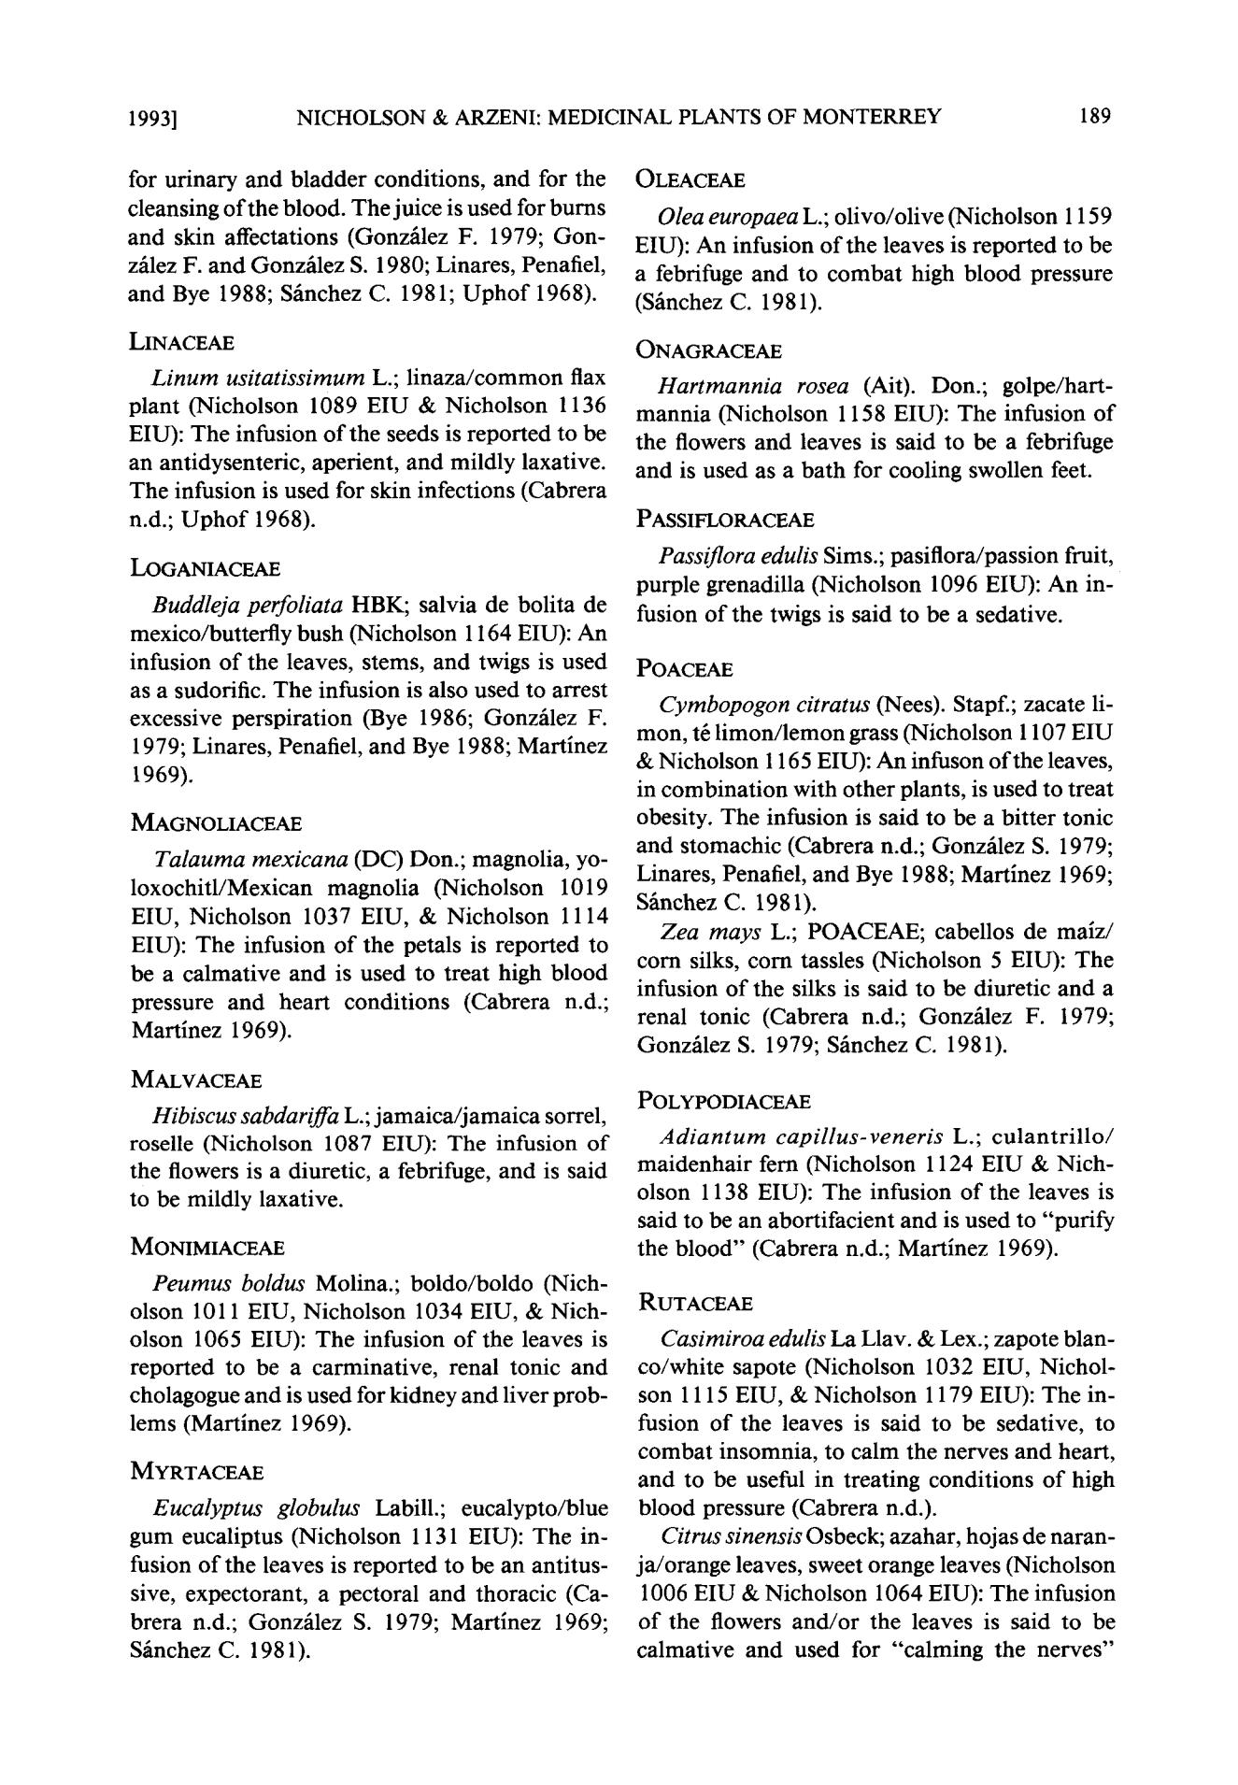1 9 9 3 ] NICHOLSON & ARZENI: MEDICINAL PLANTS OF MONTERREY 189

for urinary and bladder conditions, and for the cleansing of the blood. The juice is used for burns and skin affectations (Gonz~lez F. 1979; Gon-z~lez F. and Gonz~ilez S. 1980; Linares, Penafiel, and Bye 1988; S~inchez C. 1981; Uphof 1968).

LINACEAE

*Linum usitatissimum* L.; linaza/common flaxplant (Nicholson 1089 EIU & Nicholson 1136 EIU): The infusion of the seeds is reported to be an antidysenteric, aperient, and mildly laxative. The infusion is used for skin infections (Cabrera n.d.; Uphof 1968).

LOGANIACEAE

*Buddleja perfoliata* HBK; salvia de bolita demexico/butterfly bush (Nicholson 1164 EIU): An infusion of the leaves, stems, and twigs is used as a sudorific. The infusion is also used to arrest excessive perspiration (Bye 1986; Gonz~ilez F. 1979; Linares, Penafiel, and Bye 1988; Martinez 1969).

MAGNOLIACEAE

*Talauma mexicana* (DC) Don.; magnolia, yo-loxochitl/Mexican magnolia (Nicholson 1019 EIU, Nicholson 1037 EIU, & Nicholson 1114 EIU): The infusion of the petals is reported to be a calmative and is used to treat high blood pressure and heart conditions (Cabrera n.d.; Martinez 1969).

MALVACEAE

*Hibiscus sabdariffa* L.; jamaica/jamaica sorrel,roselle (Nicholson 1087 EIU): The infusion of the flowers is a diuretic, a febrifuge, and is said to be mildly laxative.

MONIMIACEAE

*Peumus boldus* Molina.; boldo/boldo (Nich-olson 1011 EIU, Nicholson 1034 EIU, & Nich-olson 1065 EIU): The infusion of the leaves is reported to be a carminative, renal tonic and cholagogue and is used for kidney and liver prob-lems (Martinez 1969).

MYRTACEAE

*Eucalyptus globulus* Labill.; eucalypto/bluegum eucaliptus (Nicholson 1131 EIU): The in-fusion of the leaves is reported to be an antitus-sive, expectorant, a pectoral and thoracic (Ca-brera n.d.; Gonz~lez S. 1979; Martinez 1969; S~inchez C. 1981).

OLEACEAE

*Olea europaea* L.; olivo/olive (Nicholson 1159EIU): An infusion of the leaves is reported to be a febrifuge and to combat high blood pressure (S~nchez C. 1981).

ONAGRACEAE

*Hartmannia rosea* (Ait). Don.; golpe/hart-mannia (Nicholson 1158 EIU): The infusion of the flowers and leaves is said to be a febrifuge and is used as a bath for cooling swollen feet.

PASSIFLORACEAE

*Passiflora edulis* Sims.; pasiflora/passion fruit,purple grenadilla (Nicholson 1096 EIU): An in-fusion of the twigs is said to be a sedative.

POACEAE

*Cymbopogon citratus* (Nees). Stapf.; zacate li-mon, t6 limon/lemon grass (Nicholson I 107 EIU

* Nicholson 1165 EIU): An infuson of the leaves, in combination with other plants, is used to treat obesity. The infusion is said to be a bitter tonic and stomachic (Cabrera n.d.; Gonz~ilez S. 1979; Linares, Penafiel, and Bye 1988; Martinez 1969; Sfinchez C. 1981).

*Zea mays* L.; POACEAE; cabellos de maiz/corn silks, corn tassles (Nicholson 5 EIU): The infusion of the silks is said to be diuretic and a renal tonic (Cabrera n.d.; Gonz~lez F. 1979; Gonzhlez S. 1979; Sfinchez C. 1981).

POLYPODIACEAE

*Adiantu m capillus-veneris* L.; culantrillo/maidenhair fern (Nicholson 1124 EIU & Nich-olson 1138 EIU): The infusion of the leaves is said to be an abortifacient and is used to "purify the blood" (Cabrera n.d.; Martinez 1969).

RUTACEAE

*Casimiroa edulis La* Llav. & Lex.; zapote blan-co/white sapote (Nicholson 1032 EIU, Nichol-son 1115 EIU, & Nicholson 1179 EIU): The in-fusion of the leaves is said to be sedative, to combat insomnia, to calm the nerves and heart, and to be useful in treating conditions of high blood pressure (Cabrera n.d.).

*Citrus sinensis* Osbeck; azahar, hojas de naran-ja/orange leaves, sweet orange leaves (Nicholson 1006 EIU & Nicholson 1064 EIU): The infusion of the flowers and/or the leaves is said to be calmative and used for "calming the nerves"

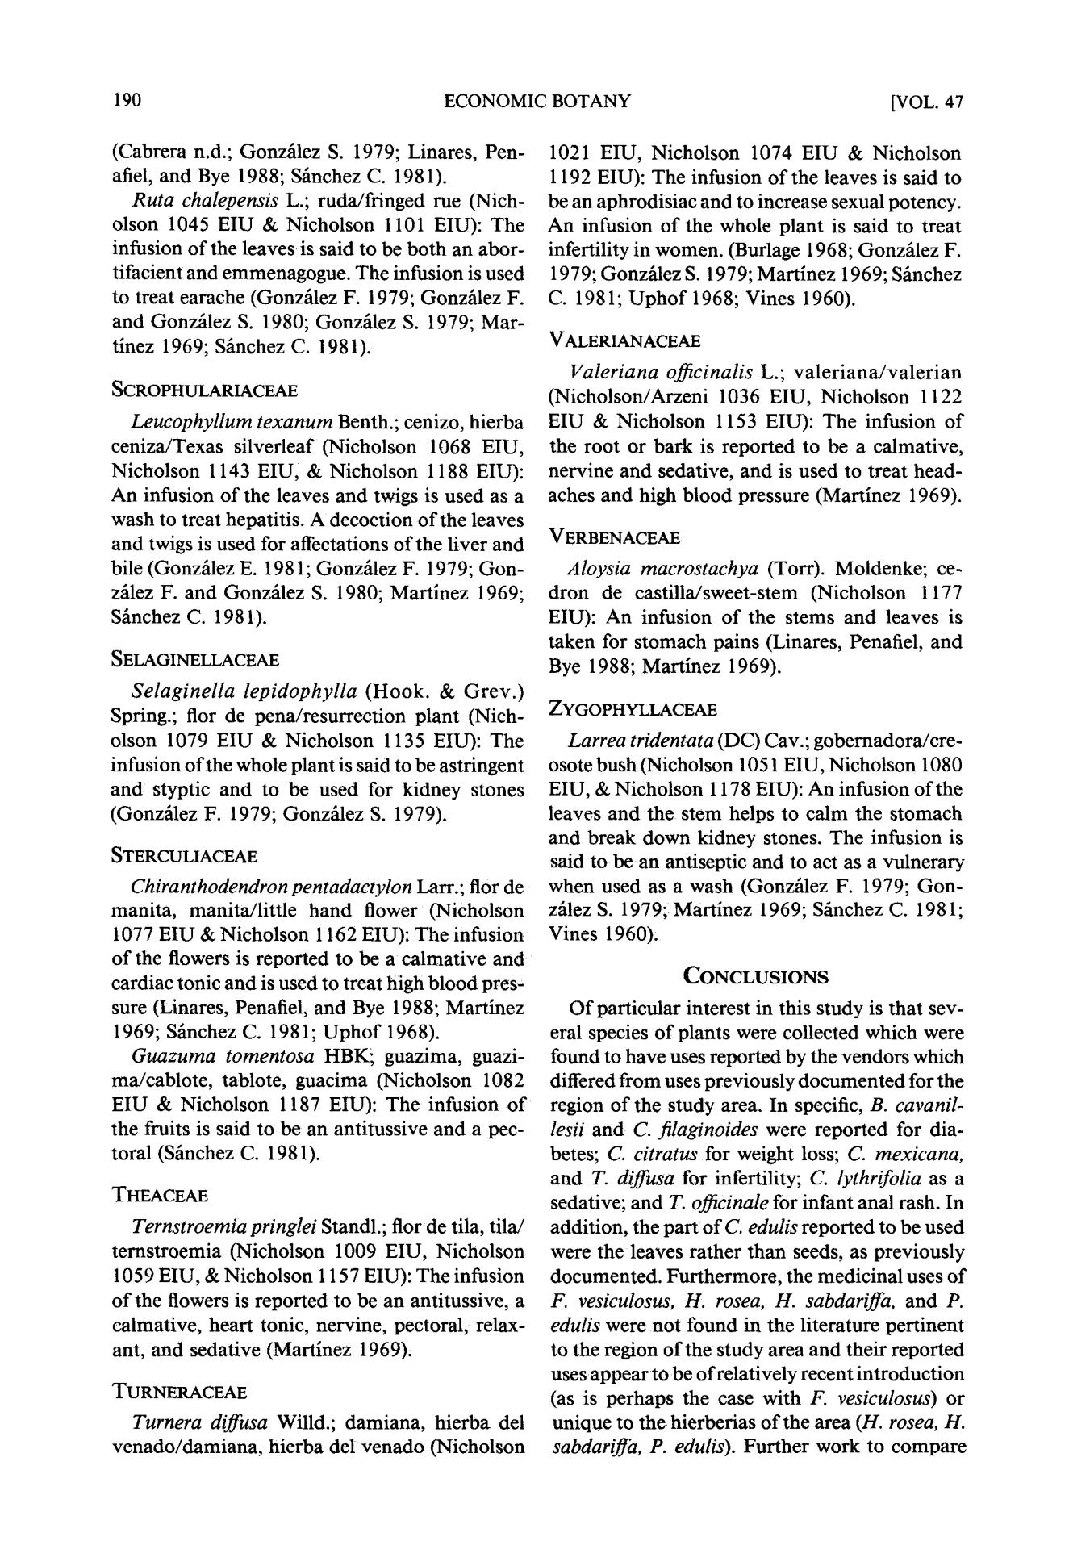190 ECONOMIC BOTANY [VOL. 47

(Cabrera n.d.; Gonzfilez S. 1979; Linares, Pen-ariel, and Bye 1988; S~nchez C. 1981).

*Ruta chalepensis* L.; ruda/fringed rue (Nich-olson 1045 EIU & Nicholson 1101 EIU): The infusion of the leaves is said to be both an abor-tifacient and emmenagogue. The infusion is used to treat earache (Gonz/dez F, 1979; Gonzfilez F. and Gonzfilez S. 1980; Gonzhlez S. 1979; Mar-tinez 1969; Sfinchez C. 1981).

SCROPHULARIACEAE

*Leucophyllum texanurn* Benth.; cenizo, hierbaceniza/Texas silverleaf (Nicholson 1068 EIU, Nicholson 1143 EIU, & Nicholson 1188 EIU): An infusion of the leaves and twigs is used as a wash to treat hepatitis. A decoction of the leaves and twigs is used for affectations of the liver and bile (Gonzfilez E. 1981; Gonzfilez F. 1979; Gon-zfilez F. and Gonzfilez S. 1980; Martinez 1969; S~nchez C. 1981).

SELAGINELLACEAE

*Selaginella lepidophylla* (Hook. & G r e v . )Spring.; flor de pena/resurrection plant (Nich-olson 1079 EIU & Nicholson 1135 EIU): The infusion of the whole plant is said to be astringent and styptic and to be used for kidney stones (Gonzfilez F. 1979; Gonzfilez S. 1979).

STERCULIACEAE

*Chiranthodendron pentadactylon* Larr.; flor demanita, manita/little hand flower (Nicholson t077 EIU & Nicholson 1162 EIU): The infusion of the flowers is reported to be a calmative and cardiac tonic and is used to treat high blood pres-sure (Linares, Penariel, and Bye 1988; Martinez 1969; Sfinchez C. 1981; Uphof 1968).

*Guazuma tomentosa* HBK~ guazima, guazi-ma/cablote, tablote, guacima (Nicholson 1082 EIU & Nicholson 1187 EIU): The infusion of the fruits is said to be an antitussive and a pec-toral (Shnchez C. 1981).

THEACEAE

*Ternstroemia pringlei* Standl.; flor de tila, tila/ternstroemia (Nicholson 1009 EIU, Nicholson 1059 EIU, & Nicholson 1157 EIU): The infusion of the flowers is reported to be an antitussive, a calmative, heart tonic, nervine, pectoral, relax-ant, and sedative (Martlnez 1969),

TURNERACEAE

*Turnera diffusa* Willd.; damiana, hierba delvenado/damiana, hierba del venado (Nieholson

1021 EIU, Nicholson 1074 EIU & Nicholson 1192 EIU): The infusion of the leaves is said to be an aphrodisiac and to increase sexual potency. An infusion of the whole plant is said to treat infertility in women. (Burlage 1968; Gonzfilez F. 1979; Gonzfilez S. 1979; Martinez 1969; Sfinchez C. 1981; Uphof 1968; Vines 1960).

VALERIANACEAE

*Valeriana o~cinalis* L.; valeriana/valerian(Nicholson/Arzeni 1036 EIU, Nicholson 1122 EIU & Nicholson 1153 EIU): The infusion of the root or bark is reported to be a calmative, nervine and sedative, and is used to treat head-aches and high blood pressure (Martinez 1969).

VERBENACEAE

*Aloysia macrostachya* (Torr). Moldenke; ce-dron de castilla/sweet-stem (Nicholson 1177 EIU): An infusion of the stems and leaves is taken for stomach pains (Linares, Penafiel, and Bye 1988; Martlnez 1969).

ZYGOPHYLLACEAE

*Larrea tridentata* (DC) Cav.; gobernadora/cre-osote bush (Nicholson 1051 EIU, Nicholson 1080 EIU, & Nicholson 1178 EIU): An infusion of the leaves and the stem helps to calm the stomach and break down kidney stones. The infusion is said to be an antiseptic and to act as a vulnerary when used as a wash (Gonzfilez F. 1979; Gon-zfilez S. 1979; Martinez 1969; S/mchez C. 1981; Vines 1960).

CONCLUSIONS

Of particular interest in this study is that sev-eral species of plants were collected which were found to have uses reported by the vendors which differed from uses previously documented for the region of the study area. In specific, *B. cavanil-lesii* and *C. fdaginoides* were reported for dia-betes; *C. citratus* for weight loss; *C. mexicana,* and *T. diffusa* for infertility; *C. lythrifolia* as a sedative; and *T. officinale* for infant anal rash. In addition, the part of *C. edulis* reported to be used were the leaves rather than seeds, as previously documented. Furthermore, the medicinal uses of *F. vesiculosus, H. rosea, H. sabdariffa,* and P. *edulis* were not found in the literature pertinentto the region of the study area and their reported uses appear to be of relatively recent introduction (as is perhaps the case with *F. vesiculosus)* or unique to the hierberias of the area *(H. rosea, H.* *sabdariffa, P. edulis).* Further work to compare

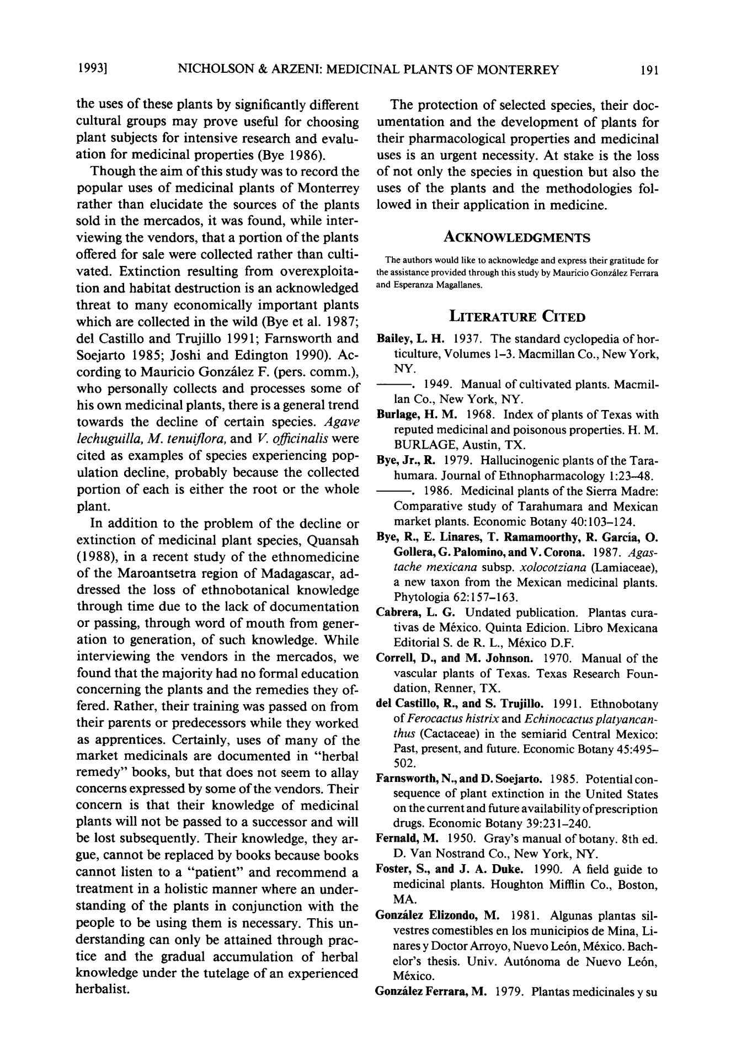1 9 9 3 ] NICHOLSON & ARZENI: MEDICINAL PLANTS OF MONTERREY 191

the uses o f these plants by significantly different cultural groups m a y prov e useful for choosing plant subjects for intensive research and evalu - ation for medicinal properties (Bye 1986).

Though the ai m o f this study was to record the popular uses o f medicinal plants o f Monterrey rather than elucidate the sources o f the plants sold in the mercados, it was found, while inter-viewing the vendors, that a portion o f the plants offered for sale were collected rather than culti-vated . Extinction resulting from overexploita - tion and habitat destruction is an acknowledged threat to man y economically importan t plants which are collected in the wild (Bye et al. 1987; del Castillo and Trujillo 1991; Farnsworth and Soejarto 1985; Joshi and Edington 1990). Ac-cording to Mauricio Gonzfilez F. (pers. comm. ), who personally collects and processes some o f his own medicinal plants, there is a general trend towards the decline o f certain species. *Agave* *lechuguilla, M. tenuiflora,* and *V. officinalis* werecited as examples o f species experiencing pop - ulation decline, probably because the collected portion o f each is either the root or the whole plant.

In additio n to the proble m o f the decline or extinction o f medicinal plant species, Quansah (1988), in a recent study o f the ethnomedicine o f the Maroantsetra region o f Madagascar, ad - dressed the loss o f ethnobotanical knowledge through time due to the lack o f documentatio n or passing, through word o f mout h from gener-ation to generation, o f such knowledge. While interviewing the vendors in the mercados, we found that the majorit y had no formal education concerning the plants and the remedies they of-fered. Rather, their training was passed on from their parents or predecessors while they worked as apprentices. Certainly, uses o f man y o f the marke t medicinals are documente d in "herbal remedy " books, but that does not seem to allay concerns expressed by some o f the vendors. Their concern is that their knowledge o f medicinal plants will not be passed to a successor and will be lost subsequently. Their knowledge, they ar-gue, cannot be replaced by books because books cannot listen to a "patient " and r e c o m m e n d a treatment in a holistic manne r where an under - standing o f the plants in conjunction with the people to be using the m is necessary. This un-derstanding can only be attained through prac-tice an d the gradual accumulation o f herbal knowledge under the tutelage o f an experienced herbalist.

The protection o f selected species, their doc-umentation and the d e v e l o p m e n t o f plants for their pharmacological properties and medicinal uses is an urgent necessity. A t stake is the loss o f not only the species in question but also the uses o f the plants and the methodologies fol-lowed in their application in medicine.

ACKNOWLEDGMENTS

The authors would like to acknowledge and express their gratitude for the assistance provided through this study by Mauricio Gonz/dez Ferrara and Esperanza Magaltanes.

LITERATURE CITED

**Bailey,** L . H . 1937. The standard cyclopedia of hor-ticulture, Volumes 1-3. Macmillan Co., New York, NY.

- - . 1949. Manual of cultivated plants. Macmil-

lan Co., New York, NY.

Bnrlage, H . M . 1968. Index of plants of Texas with reputed medicinal and poisonous properties. H. M. BURLAGE, Austin, TX.

Bye, Jr., R. 1979. Hallucinogenic plants of the Tara-humara. Journal of Ethnopharmacology 1:23--48.

- - . 1986. Medicinal plants of the Sierra Madre:

Comparative study of Tarahumara and Mexican

market plants. Economic Botany 40:103-124.

**Bye, R., E. Linares, T. Ramamoorthy, R. Garcia, O.**

Gollera, G. Palomino, and V. Corona. 1987. *Agas-tache mexicana* subsp, *xolocotziana* (Lamiaceae),a new taxon from the Mexican medicinal plants. Phytologia 62:157-163.

**Cahrera,** L. G. Undated publication. Plantas cura-tivas de M6xico. Quinta Edicion. Libro Mexicana Editorial S. de R. L., M6xico D.F.

Correll, D., and M. Johnson. 1970. Manual of the vascular plants of Texas. Texas Research Foun-dation, Renner, TX.

**del Castillo, R., and S. Trujillo. 1991.** Ethnobotany

of *Ferocactus histrix* and *Echinocactus platyancan-thus* (Cactaceae) in the semiarid Central Mexico:Past, present, and future. Economic Botany 45:495-502.

**Farnsworth, N.,andD. Soejarto.** 1985. Potentialcon-sequence of plant extinction in the United States on the current and future availabilityof prescription drugs. Economic Botany 39:231-240.

**Fernald,** M. 1950. Gray's manual of botany. 8th ed.

D. Van Nostrand Co., New York, NY.

**Foster, S., and J. A. Duke.** **1990. A** field guide tomedicinal plants. Houghton Mifflin Co., Boston, MA.

**Gonzhlez Elizondo, M.** 1981. Algunas plantas sil-vestres comestibles en los municipios de Mina, Li-nares y Doctor Arroyo, Nuevo Le6n, M6xico. Bach-elor's thesis. Univ. Aut6noma de Nuevo Le6n, M6xico.

**GonzfilezFerrara, M.** 1979. Plantasmedicinalesysu

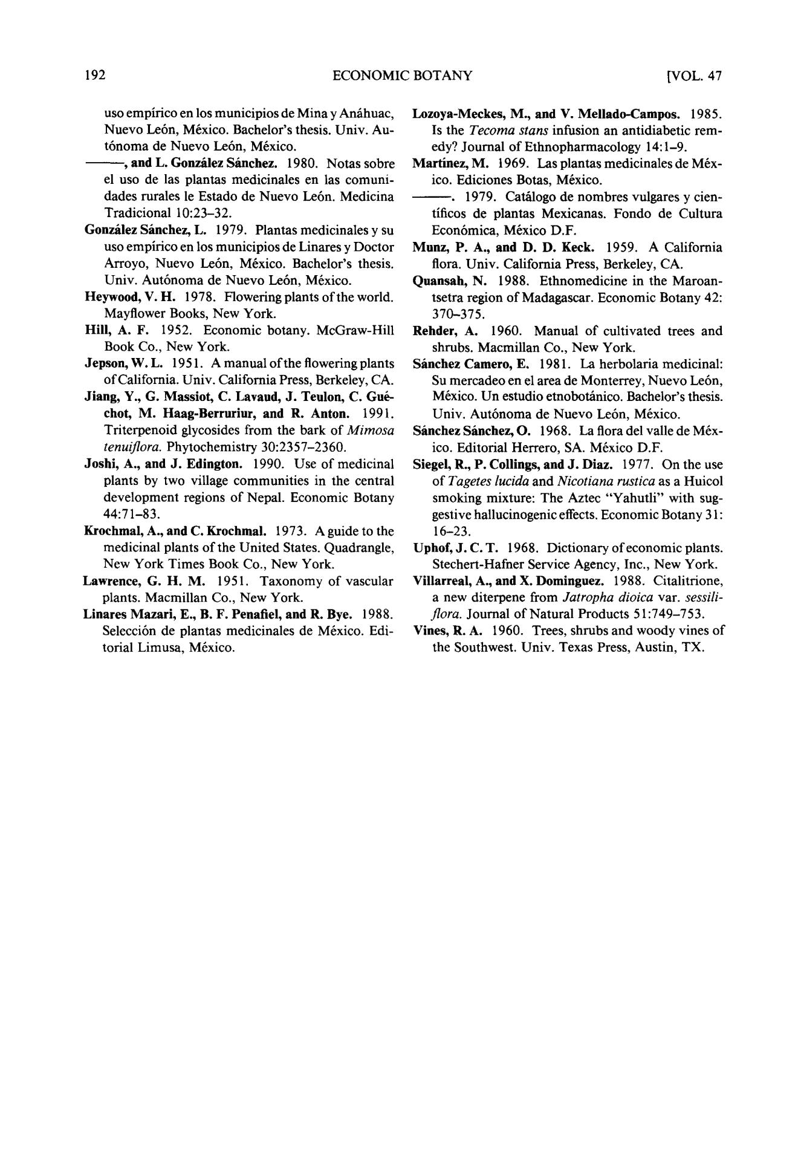192 ECONOMIC BOTANY [VOL. 47

uso empirico en los municipios de Mina y Anfihuac, Nuevo Le6n, M6xico. Bachelor's thesis. Univ. Au-t6noma de Nuevo Le6n, M6xico.

* and L Gonz/flez Sfinehez. 1980. Notas sobre el uso de las plantas medicinales en las comuni-dades rurales le Estado de Nuevo Le6n. Medicina Tradicional 10:23-32.

Gonz~lezS~inchez, L. 1979. Plantasmedicinalesysu uso empirico en los municipios de Linares y Doctor Arroyo, Nuevo Le6n, M6xico. Bachelor's thesis. Univ. Aut6noma de Nuevo Le6n, M6xico.

**Heywood,** V . H . 1978. Flowering plants of the world.

Mayflower Books, New York.

Hill, A . F . 1952. Economic botany. McGraw-Hill Book Co., New York.

**Jepson,** W . L . 1951. A manual of the flowering plants of California. Univ. California Press, Berkeley, CA.

Jiang, Y., G. Massiot, C. Lavand, J . Teulon, C. Gu6-chot, M. **Haag-Berrurinr, and** R. Anton. 1991. Triterpenoid glycosides from the bark of *Mimosa* *tenuiflora.* Phytochemistry 30:2357-2360.

Joshi, A., and J . Edington. 1990. Use of medicinal plants by two village communities in the central development regions of Nepal. Economic Botany 44:71-83.

Krochmal, A., and C. Krochmal. 1973. A guide to the medicinal plants of the United States. Quadrangle, New York Times Book Co., New York.

**Lawrence,** G. H. M. 1951. Taxonomy of vascular plants. Macmillan Co., New York.

**Linares Mazari, E., B. F. Penafiel, and R. Bye.** 1988.

Selecci6n de plantas medicinales de M6xico. Edi-torial Limusa, M6xico.

**Lozoya-Meckes, M., and V.** Mellado-Campos. 1985. Is the *Tecoma stans* infusion an antidiabetic rem-edy? Journal of Ethnopharmacology 14:1-9.

Martinez, M. 1969. Las plantas medicinales de M6x-ico. Ediciones Botas, M6xico.

- - . 1979. Catfilogo de nombres vulgares y cien-tificos de plantas Mexicanas. Fondo de Cultura Econ6mica, M6xico D.F.

Manz, P. A., and D. D. Keck. 1959. A California flora. Univ. California Press, Berkeley, CA.

Qnansah, N. 1988. Ethnomedicine in the Maroan-tsetra region of Madagascar. Economic Botany 42: 370-375.

**Rehder,** A. 1960. Manual of cultivated trees and shrubs. Macmillan Co., New York.

S~inchez Camero, E. 1981. La herbolaria medicinal: Su mercadeo en el area de Monterrey, Nuevo Le6n, M6xico. Un estudio etnobotfinico. Bachelor's thesis. Univ. Aut6noma de Nuevo Le6n, M6xico.

S~inchez Sfinchez, O. 1968. La flora del vaUe de M6x-ico. Editorial Herrero, SA. M6xico D.F.

Siegel, R., P. Collings, and J . Diaz. 1977. On the use of *Tagetes lucida* and *Nicotiana rustica* as a Huicol smoking mixture: The Aztec "Yahutli" with sug-gestive hallucinogenic effects, Economic Botany 31: 16-23.

Uphof, J . C . T . 1968. Dictionary of economic plants.

Stechert-Hafner Service Agency, Inc., New York.

Villarreal, A., and X. Dominguez. 1988. Citalitrione, a new diterpene from *Jatropha dioica* var. *sessili-flora.* Journal of Natural Products 51:749-753.

**Vines,** R . A . 1960. Trees, shrubs and woody vines ofthe Southwest. Univ. Texas Press, Austin, TX.